Joyful Mysteries
- Annunciation/ Incarnation
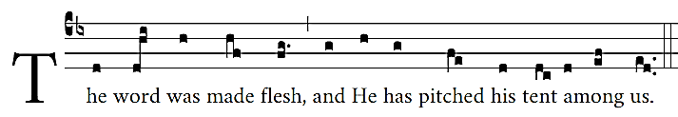
Tone Id
- Visitation
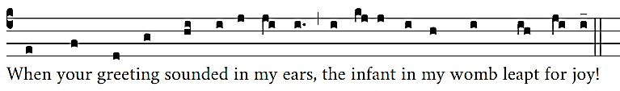
Tone IIIb
- Nativity
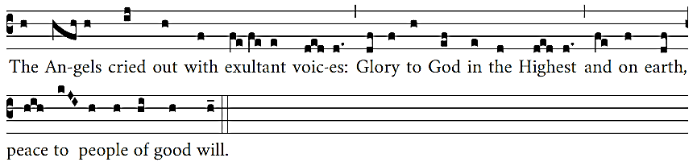
Tone Va2
- Presentation
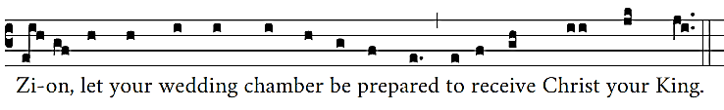
Tone VIId
- Manifestation in the Temple
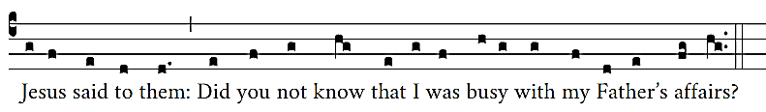
Tone VIIIg2
Glorious Mysteries
- Resurrection
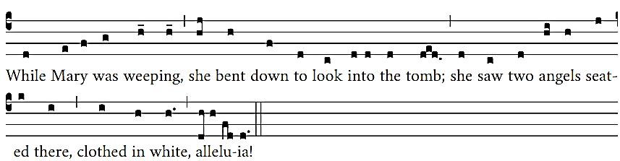
Tone Id3
- Ascension
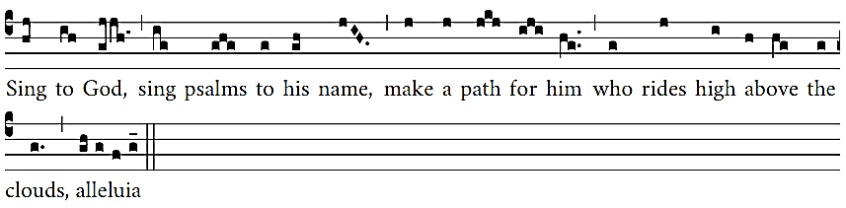
Tone VIIIg
- Descent of the Holy Spirit
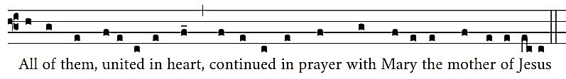
- Assumption BVM
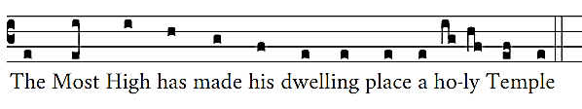
Tone VIIc2
- Coronation BVM
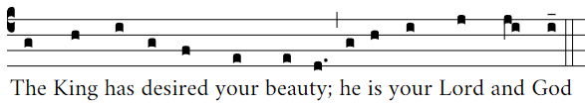
Tone IIIb
Sorrowful Mysteries
- Agony in the Garden
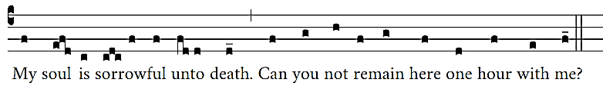
Tone VIf
- Scourging at the Pillar
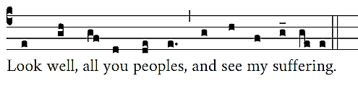
Tone IVe
- Crowning with Thorns
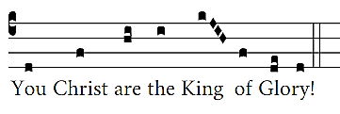
Tone Va
- Jesus embraces His Cross
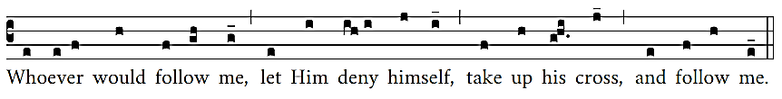
Tone VIIc
- Crucifixion and Death of Our Lord
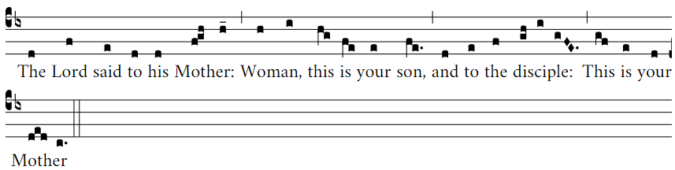
Tonus Peregrinus
Luminous Mysteries
- Baptism in the Jordan
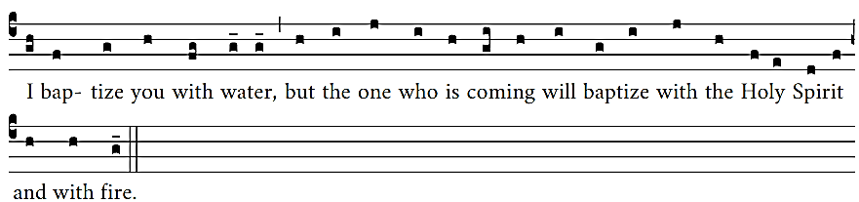
Tone VIIIg
- Manifestation at Cana
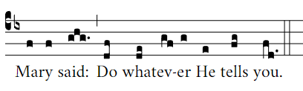
Tone Id3
- Proclamation of the Kingdom
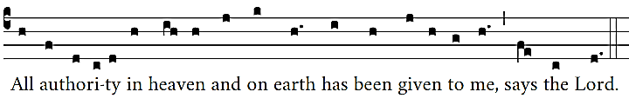
Tone Id2
- Transfiguration
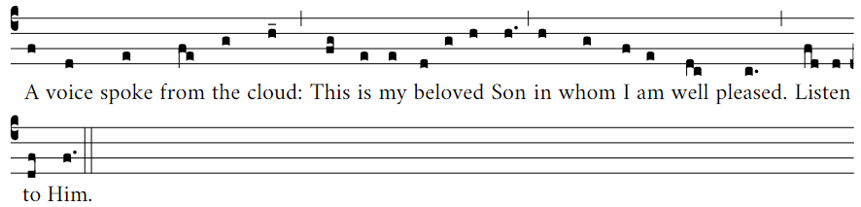
Tone IVg
- Institution of the Eucharist and the Priesthood
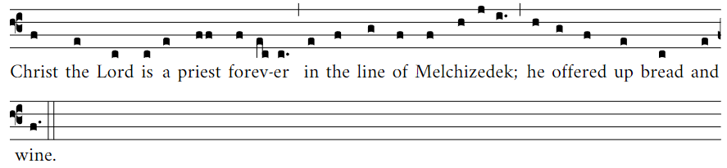
Tone IId

