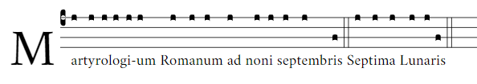
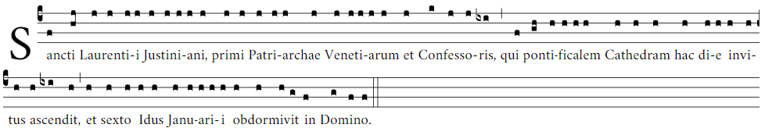
…
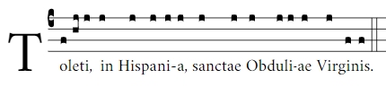 (this is used when there are shorter martyrologies with just the name and place)
