English Hymn from Fr. Samuel Weber OSB- Free permission to copy and distribute
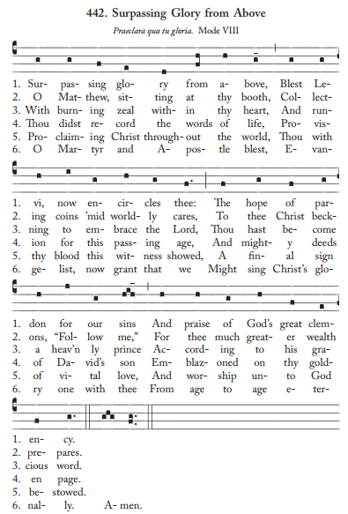
Latin Version https://gregobase.selapa.net/chant.php?id=9132

