Psalm 104: 1-2, 5-6, 10-14, 24, 35 *Benedic, anima mea*

*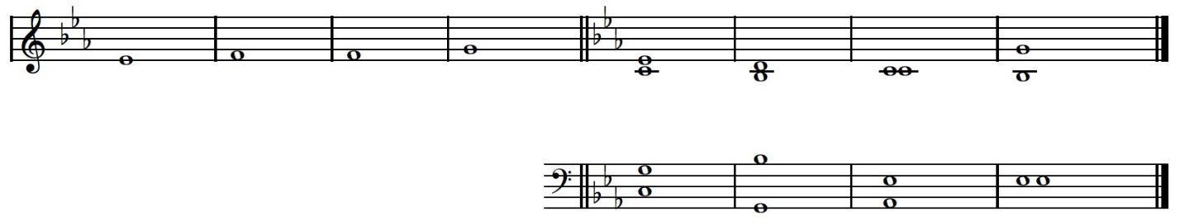*

Praise the LORD, O my soul: O LORD my God, thou art become exceeding / glorious; \* thou art cloth-ed with majesty and / honor. //

Thou deckest thyself with light as it were with a / garment, \* and spreadest out the heavens like a / curtain.

He laid the foundations of the / earth \* that it never should move at any / time. //

Thou cover-edst it with the deep like as with a / garment; \* the waters stand above the / hills.

He sendeth the springs into the / rivers, \* which run among the| hills //

All beasts of the field / drink thereof, \* and the wild asses quench their / thirst.

Beside them shall the fowls of the air have their habit- / ation, \* and sing among the / branches. //

He watereth the hills from a- / bove; \* the earth is filled with the fruit of thy / works.

He bringeth forth grass for the / cattle, \* and green herb for the service of / men; //

O LORD, how manifold are thy / works! \* in wisdom hast thou made them all; the earth is full

of thy / riches.

As for sinners, they shall be consum-ed out of the / earth, \* and the ungodly shall come

to an / end //

Praise thou the LORD, O my / soul. \* Praise the / LORD.

Psalm 16: 5, 8-11 *Conserva me, Domine*

**

Their drink-offerings of blood will I not / offer, \* neither make mention of their names with- / in my lips.

I will thank the LORD for giving me / warning; \* my reins also chasten me in the / night season.

I have set the LORD alway be- / fore me; \* for he is on my right hand, therefore I / shall not fall.

Wherefore my heart is glad, and my glory re- / joiceth: \* my flesh also shall / rest in hope.

For why? thou shalt not leave my soul in / hell; \* neither shalt thou suffer thy Holy One to / see corruption.

Canticle, Exodus 15: 1-6, 17-18 *Cantemus Domino*

**

I will sing unto the LORD, for he hath triumph’d / gloriously: \* the horse and his rider hath he thrown into the / sea //

The LORD is my strength and / song: \* and he is become my sal- / vation

He is my God, and I will prepare him an habi- / tation: \* my father’s God and I will ex- / alt him. //

The LORD is a man of / war: \* the LORD is his / Name.

Pharaoh’s chariots and his host hath he cast into the / sea: \* his chosen captains also are drown-ed in the / Red Sea. //

The depths have / cover-ed them: \* they sank into the bottom as a / stone

Thy right hand, O LORD, is become glorious in / power: \* thy right hand, O LORD, hath dash-ed in pieces the / enemy //

Thou shalt bring them in and / plant them \* In the mountain of thine in- / heritance

In the place, O / LORD, \* which thou hast made for thee to / dwell in: //

In the sanctuary, O LORD, which thy hands have es- / stablish-ed. \* The LORD shall reign for ever and for- / ever.

Psalm 30: 1-5, 10-12



I will magnify thee, O LORD; for thou hast set me / up, \* and not made my foes to / triumph over me.

O LORD my God, I cri-ed / unto thee; \* and / thou hast heal-ed me.

Thou, LORD, hast brought my soul out of / hell: \* thou hast kept my life, that I should not go / down into the pit.

Sing praises unto the LORD, O ye / saints of his; \* and give thanks unto him, for a remembrance / of his holiness

For his wrath endureth but the twinkling of an eye, and in his pleasure is / life; \* heaviness may endure for a night, but joy cometh / in the morning.

Hear, O LORD, and have mercy up- / on me; \* LORD, be / thou my helper

Thou hast turn-ed my heaviness into / joy; \* thou hast put off my sackcloth, and gird-ed / me with gladness:

Therefore shall every good man sing of thy praise without / ceasing. \* O my God, I will give thanks unto / thee forever.

Canticle, Isaiah 12: 2-6 *Ecce, Deus*

**

Behold, God is my sal- / vation; \* I will trust and not be a- / fraid. //

For the Lord God is my strength and my / song; \* he also is become my sal- / vation.

Therefore with joy shall ye draw / water \* out of the wells of sal- / vation. //

And in that day ye shall / say, \* Praise the Lord, call upon his / Name,

Declare his doings among the / people, \* make mention that his Name is ex- / alt-ed. //

Sing unto the Lord, for he hath done excellent things: \* this is known in all the / earth.

Cry out and / shout, \* thou inhabitant of / Zion: //

For great is the Holy One of / Israel \* in the midst of / thee.

Psalm 19: 7-10 *Lex Domini Immaculata*



The law of the Lord is an undefil-ed law, converting the / soul; \* the testimony of the Lord is sure, and giveth wisdom unto / the simple.

The statutes of the Lord are right, and rejoice the / heart; \* the commandment of the Lord is pure, and giveth

light unto / the *eyes.*

The fear of the Lord is clean, and endureth for / ever; \* the judgments of the Lord are true, and righteous al- / together.

More to be desir-ed are they than gold, yea, than much fine / gold; \* sweeter also than honey, and / the honeycomb.

Psalm 42: 2, 4 and Psalm 43: 3, 4



My soul is athirst for / God \* yea, even for the living / God: //

when shall I come to ap- / pear \* before the presence of / God?

Now when I think thereupon, I pour out my heart by my- / self; \* for I went with the multitude, and brought them forth into the house of / God. //

In the voice of praise and thanks- / giving, \* among such as keep holy- / day.

O send out thy light and thy / truth, \* that they may / lead me, //

and bring me unto thy holy / hill, \* and to thy / dwelling;

And that I may go unto the altar of / God, \* even unto the God of my joy and / gladness; //

and upon the / harp \* will I give thanks unto thee, O God my / God.