Nota Bene:
The application of Gregorian Tones to the English Vernacular is a subject of study, particularly among those who chant the Divine Office Daily in choir.

The Latin Language differs from English in the common place that a stress or accent is placed in a sentence. In English, the stress is often placed at the end of the sentence, and often with single syllable words (as in French for example). However, in Latin the stress is often placed a little before the end of the sentence (as in Italian for example).

Some communities adapt the Gregorian to the English Language. Doing this however, they are forced to change the melody of the traditional tone. In favor of keeping the original Gregorian Tone, we have chosen to instead adapt the English to the Gregorian, not vice-versa. We do this by a method of counting syllables (2 or 3 syllables representing the stress from the end of the sentence (depending on what sounds best to the ear) and finding the other movements based on that stress. At times a word or two might sound unnatural to the English ear but this in favor of having a method that fits the Gregorian Tone and also is able to be applied to the Breviary without having to print out pointers- it is one that can be learned easily with practice so that the liturgy can be prayed using the mandated books- causing less distraction and more focus on prayer.

We are grateful to Professor Christian Alejandro Almada, Organist of the Titular Basilica of Saint Paul’s Outside the Walls in Rome for his help in establishing this method according to the standards given by Solesmes and the Pontifical Academy of Sacred Music.

Applying the Gregorian Tones to English

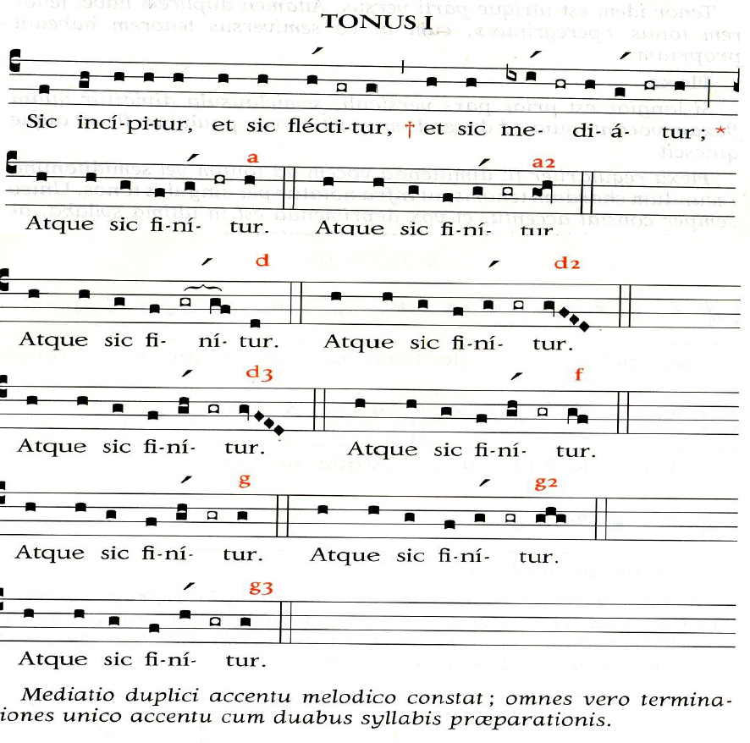

(without incipit) The Lord is my shepherd;*
there is nothing I shall want.
Fresh and green are the pastures*
where he gives me repose.
Near restful waters he leads me,*
to revive my drooping spirit.
When I call, answer me, O God of justice;*
from anguish you released me, have mercy and hear me!*
O men, how long will your hearts be closed,*
will you love what is futile and seek what is false?
It is the Lord who grants favors to those whom he loves;*
the Lord hears me whenever I call him.
Fear him; do not sin: ponder on your bed and be still*
Make justice your sacrifice, and trust in the Lord.
“What can bring us happiness?” many say.*
Let the light of your face shine on us, O Lord.
You have put into my heart a greater joy*
than they have from abundance of corn and new wine.
I will lie down in peace and sleep comes at once*
for you alone, Lord, make me dwell in safety.
Glory to the Father and to the Son*
And to the Holy Spirit

As it was in the beginning is now*
And will be forever. Amen

He guides me along the right path;*
he is true to his name.
If I should walk in the valley of darkness*
no evil would I fear.
You are there with your crook and your staff;*
with these you give me comfort.
You have prepared a banquet for me*
in the sight of my foes.
My head you have anointed with oil;*
my cup is overflowing.
Surely goodness and kindness shall follow me*
all the days of my life.
In the Lord’s own house shall I dwell*
for ever and ever.
Glory to the Father and to the Son*
And to the Holy Spirit
As it was in the beginning is now *
And will be forever. Amen

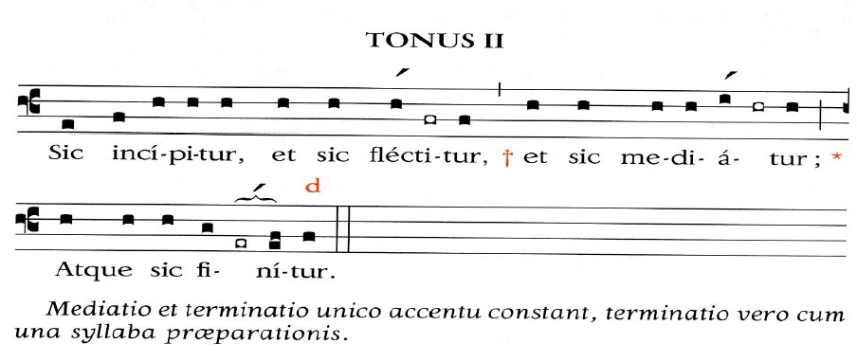
When I call, answer me, O God of justice;*
from anguish you released me, have mercy and hear me!*
O men, how long will your hearts be closed,*
will you love what is futile and seek what is false?
It is the Lord who grants favors to those whom he loves;*
the Lord hears me whenever I call him.
Fear him; do not sin: ponder on your bed and be still*
Make justice your sacrifice, and trust in the Lord.
“What can bring us happiness?” many say.*
Let the light of your face shine on us, O Lord.
You have put into my heart a greater joy*
than they have from abundance of corn and new wine.
I will lie down in peace and sleep comes at once*
for you alone, Lord, make me dwell in safety.
Glory to the Father and to the Son*
And to the Holy Spirit

As it was in the beginning is now*
And will be forever. Amen

(without incipit) The Lord is my shepherd;*
there is nothing I shall want.
Fresh and green are the pastures*
where he gives me repose.
Near restful waters he leads me,*
to revive my drooping spirit.
He guides me along the right path;*
he is true to his name.
If I should walk in the valley of darkness*
no evil would I fear.
You are there with your crook and your staff;*
with these you give me comfort.
You have prepared a banquet for me*
in the sight of my foes.
My head you have anointed with oil;*
my cup is overflowing.
Surely goodness and kindness shall follow me*
all the days of my life.
In the Lord’s own house shall I dwell*
for ever and ever.
Glory to the Father and to the Son*
And to the Holy Spirit
As it was in the beginning is now *
And will be forever. Amen
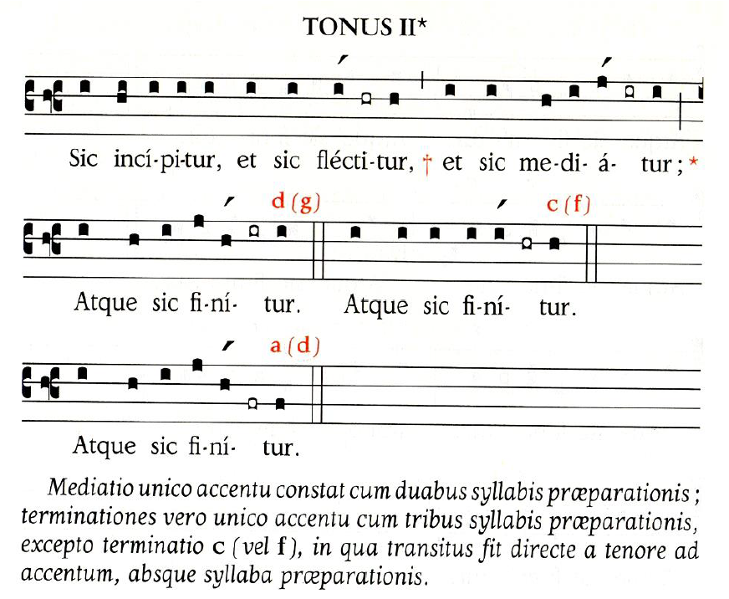
(See tone 4)

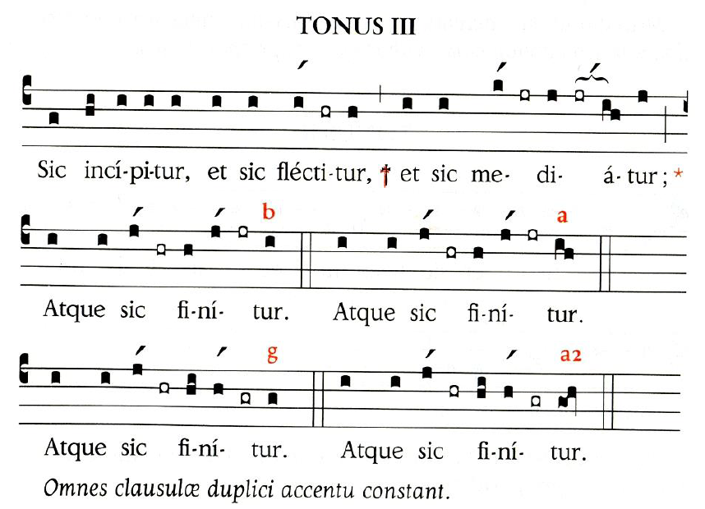
( without incipit) The Lord is my shepherd;*
there is nothing I shall want.
Fresh and green are the pastures*
where he gives me repose.
Near restful waters he leads me,*
to revive my drooping spirit.
When I call, answer me, O God of justice;*
from anguish you released me, have mercy and hear me!*
O men, how long will your hearts be closed,*
will you love what is futile and seek what is false?
It is the Lord who grants favors to those whom he loves;*
the Lord hears me whenever I call him.
Fear him; do not sin: ponder on your bed and be still*
Make justice your sacrifice, and trust in the Lord.
“What can bring us happiness?” many say.*
Let the light of your face shine on us, O Lord.
You have put into my heart a greater joy*
than they have from abundance of corn and new wine.
I will lie down in peace and sleep comes at once*
for you alone, Lord, make me dwell in safety.
Glory to the Father and to the Son*
And to the Holy Spirit

As it was in the beginning is now*
And will be forever. Amen

He guides me along the right path;*
he is true to his name.
If I should walk in the valley of darkness*
no evil would I fear.
You are there with your crook and your staff;*
with these you give me comfort.
You have prepared a banquet for me*
in the sight of my foes.
My head you have anointed with oil;*
my cup is overflowing.
Surely goodness and kindness shall follow me*
all the days of my life.
In the Lord’s own house shall I dwell*
for ever and ever.
Glory to the Father and to the Son*
And to the Holy Spirit
As it was in the beginning is now *
And will be forever. Amen
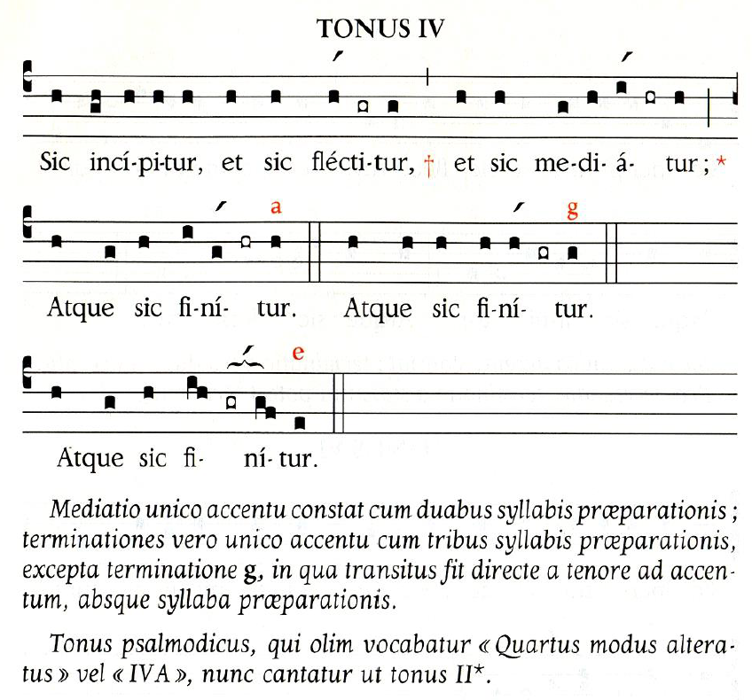
When I call, answer me, O God of justice;*
from anguish you released me, have mercy and hear me!*
O men, how long will your hearts be closed,*
will you love what is futile and seek what is false?
It is the Lord who grants favors to those whom he loves;*
the Lord hears me whenever I call him.
Fear him; do not sin: ponder on your bed and be still*
Make justice your sacrifice, and trust in the Lord.
“What can bring us happiness?” many say.*
Let the light of your face shine on us, O Lord.
You have put into my heart a greater joy*
than they have from abundance of corn and new wine.
I will lie down in peace and sleep comes at once*
for you alone, Lord, make me dwell in safety.
Glory to the Father and to the Son*
And to the Holy Spirit

As it was in the beginning is now*
And will be forever. Amen

( without incipit) The Lord is my shepherd;*
there is nothing I shall want.
Fresh and green are the pastures*
where he gives me repose.
Near restful waters he leads me,*
to revive my drooping spirit.
He guides me along the right path;*
he is true to his name.
If I should walk in the valley of darkness*
no evil would I fear.
You are there with your crook and your staff;*
with these you give me comfort.
You have prepared a banquet for me*
in the sight of my foes.
My head you have anointed with oil;*
my cup is overflowing.
Surely goodness and kindness shall follow me*
all the days of my life.
In the Lord’s own house shall I dwell*
for ever and ever.
Glory to the Father and to the Son*
And to the Holy Spirit
As it was in the beginning is now *
And will be forever. Amen
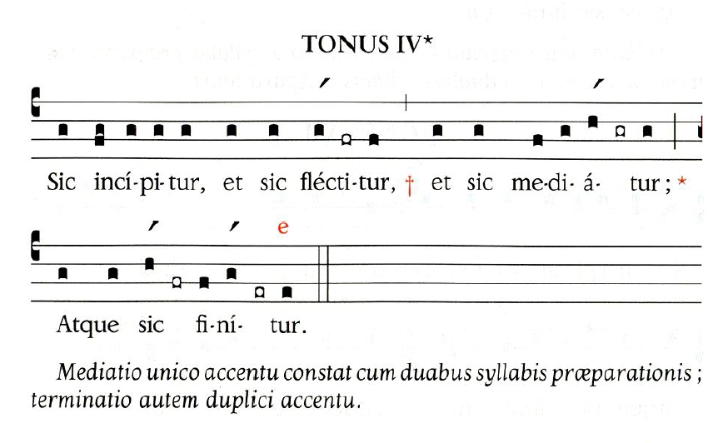
(see tone 4 above- same principles)

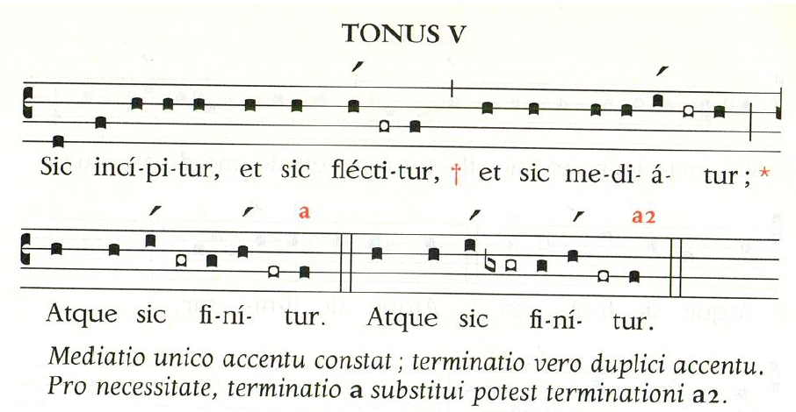

(without incipit) The Lord is my shepherd;*
there is nothing I shall want.
Fresh and green are the pastures*
where he gives me repose.
Near restful waters he leads me,*
to revive my drooping spirit.
When I call, answer me, O God of justice;*
from anguish you released me, have mercy and hear me!*
O men, how long will your hearts be closed,*
will you love what is futile and seek what is false?
It is the Lord who grants favors to those whom he loves;*
the Lord hears me whenever I call him.
Fear him; do not sin: ponder on your bed and be still*
Make justice your sacrifice, and trust in the Lord.
“What can bring us happiness?” many say.*
Let the light of your face shine on us, O Lord.
You have put into my heart a greater joy*
than they have from abundance of corn and new wine.
I will lie down in peace and sleep comes at once*
for you alone, Lord, make me dwell in safety.
Glory to the Father and to the Son*
And to the Holy Spirit

As it was in the beginning is now*
And will be forever. Amen

He guides me along the right path;*
he is true to his name.
If I should walk in the valley of darkness*
no evil would I fear.
You are there with your crook and your staff;*
with these you give me comfort.
You have prepared a banquet for me*
in the sight of my foes.
My head you have anointed with oil;*
my cup is overflowing.
Surely goodness and kindness shall follow me*
all the days of my life.
In the Lord’s own house shall I dwell*
for ever and ever.
Glory to the Father and to the Son*
And to the Holy Spirit
As it was in the beginning is now *
And will be forever. Amen
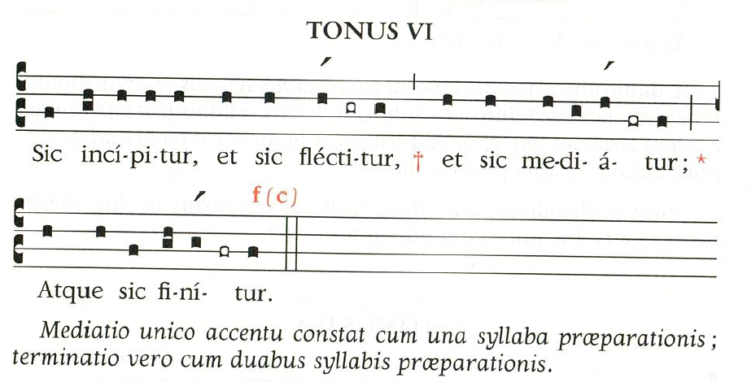
(without incipit) The Lord is my shepherd;*
there is nothing I shall want.
Fresh and green are the pastures*
where he gives me repose.
Near restful waters he leads me,*
to revive my drooping spirit.
When I call, answer me, O God of justice;*
from anguish you released me, have mercy and hear me!*
O men, how long will your hearts be closed,*
will you love what is futile and seek what is false?
It is the Lord who grants favors to those whom he loves;*
the Lord hears me whenever I call him.
Fear him; do not sin: ponder on your bed and be still*
Make justice your sacrifice, and trust in the Lord.
“What can bring us happiness?” many say.*
Let the light of your face shine on us, O Lord.
You have put into my heart a greater joy*
than they have from abundance of corn and new wine.
I will lie down in peace and sleep comes at once*
for you alone, Lord, make me dwell in safety.
Glory to the Father and to the Son*
And to the Holy Spirit

As it was in the beginning is now*
And will be forever. Amen

He guides me along the right path;*
he is true to his name.
If I should walk in the valley of darkness*
no evil would I fear.
You are there with your crook and your staff;*
with these you give me comfort.
You have prepared a banquet for me*
in the sight of my foes.
My head you have anointed with oil;*
my cup is overflowing.
Surely goodness and kindness shall follow me*
all the days of my life.
In the Lord’s own house shall I dwell*
for ever and ever.
Glory to the Father and to the Son*
And to the Holy Spirit
As it was in the beginning is now *
And will be forever. Amen
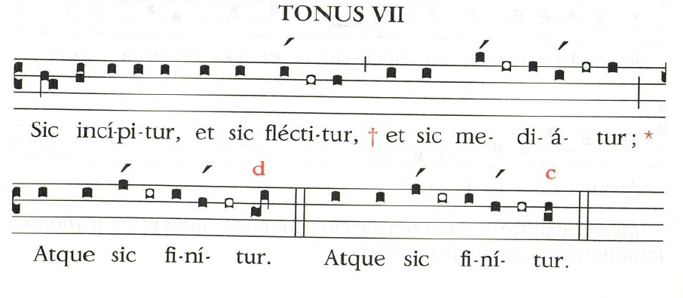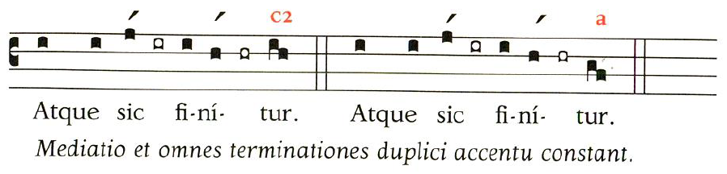
When I call, answer me, O God of justice;*
from anguish you released me, have mercy and hear me!*
O men, how long will your hearts be closed,*
will you love what is futile and seek what is false?
It is the Lord who grants favors to those whom he loves;*
the Lord hears me whenever I call him.
Fear him; do not sin: ponder on your bed and be still*
Make justice your sacrifice, and trust in the Lord.
“What can bring us happiness?” many say.*
Let the light of your face shine on us, O Lord.
You have put into my heart a greater joy*
than they have from abundance of corn and new wine.
I will lie down in peace and sleep comes at once*
for you alone, Lord, make me dwell in safety.
Glory to the Father and to the Son*
And to the Holy Spirit

As it was in the beginning is now*
And will be forever. Amen

(without incipit) The Lord is my shepherd;*
there is nothing I shall want.
Fresh and green are the pastures*
where he gives me repose.
Near restful waters he leads me,*
to revive my drooping spirit.
He guides me along the right path;*
he is true to his name.
If I should walk in the valley of darkness*
no evil would I fear.
You are there with your crook and your staff;*
with these you give me comfort.
You have prepared a banquet for me*
in the sight of my foes.
My head you have anointed with oil;*
my cup is overflowing.
Surely goodness and kindness shall follow me*
all the days of my life.
In the Lord’s own house shall I dwell*
for ever and ever.
Glory to the Father and to the Son*
And to the Holy Spirit
As it was in the beginning is now *
And will be forever. Amen
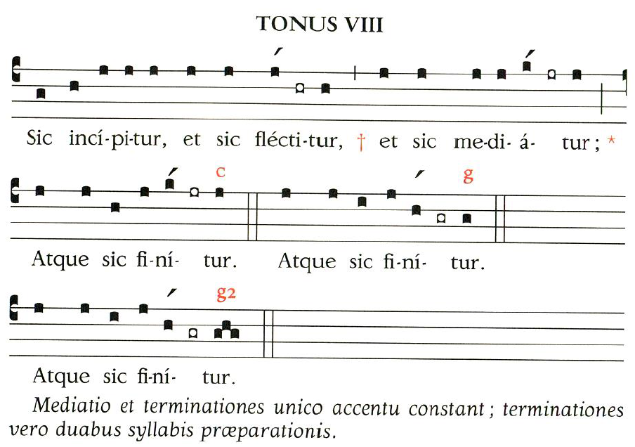
When I call, answer me, O God of justice;*
from anguish you released me, have mercy and hear me!*
O men, how long will your hearts be closed,*
will you love what is futile and seek what is false?
It is the Lord who grants favors to those whom he loves;*
the Lord hears me whenever I call him.
Fear him; do not sin: ponder on your bed and be still*
Make justice your sacrifice, and trust in the Lord.
“What can bring us happiness?” many say.*
Let the light of your face shine on us, O Lord.
You have put into my heart a greater joy*
than they have from abundance of corn and new wine.
I will lie down in peace and sleep comes at once*
for you alone, Lord, make me dwell in safety.
Glory to the Father and to the Son*
And to the Holy Spirit

As it was in the beginning is now*
And will be forever. Amen

without incipit) The Lord is my shepherd;*
there is nothing I shall want.
Fresh and green are the pastures*
where he gives me repose.
Near restful waters he leads me,*
to revive my drooping spirit.
He guides me along the right path;*
he is true to his name.
If I should walk in the valley of darkness*
no evil would I fear.
You are there with your crook and your staff;*
with these you give me comfort.
You have prepared a banquet for me*
in the sight of my foes.
My head you have anointed with oil;*
my cup is overflowing.
Surely goodness and kindness shall follow me*
all the days of my life.
In the Lord’s own house shall I dwell*
for ever and ever.
Glory to the Father and to the Son*
And to the Holy Spirit
As it was in the beginning is now *
And will be forever. Amen
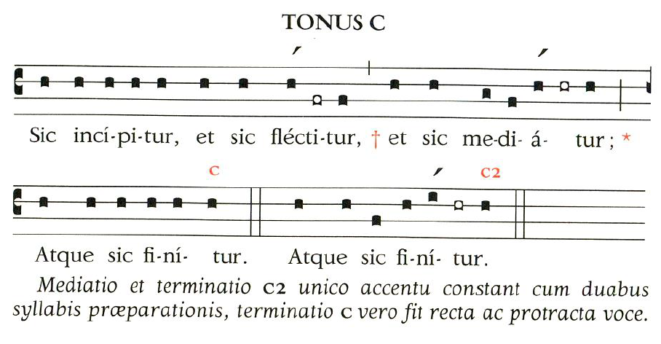
When I call, answer me, O God of justice;*
from anguish you released me, have mercy and hear me!*
O men, how long will your hearts be closed,*
will you love what is futile and seek what is false?
It is the Lord who grants favors to those whom he loves;*
the Lord hears me whenever I call him.
Fear him; do not sin: ponder on your bed and be still*
Make justice your sacrifice, and trust in the Lord.
“What can bring us happiness?” many say.*
Let the light of your face shine on us, O Lord.
You have put into my heart a greater joy*
than they have from abundance of corn and new wine.
I will lie down in peace and sleep comes at once*
for you alone, Lord, make me dwell in safety.
Glory to the Father and to the Son*
And to the Holy Spirit

As it was in the beginning is now*
And will be forever. Amen

without incipit) The Lord is my shepherd;*
there is nothing I shall want.
Fresh and green are the pastures*
where he gives me repose.
Near restful waters he leads me,*
to revive my drooping spirit.
He guides me along the right path;*
he is true to his name.
If I should walk in the valley of darkness*
no evil would I fear.
You are there with your crook and your staff;*
with these you give me comfort.
You have prepared a banquet for me*
in the sight of my foes.
My head you have anointed with oil;*
my cup is overflowing.
Surely goodness and kindness shall follow me*
all the days of my life.
In the Lord’s own house shall I dwell*
for ever and ever.
Glory to the Father and to the Son*
And to the Holy Spirit
As it was in the beginning is now *
And will be forever. Amen
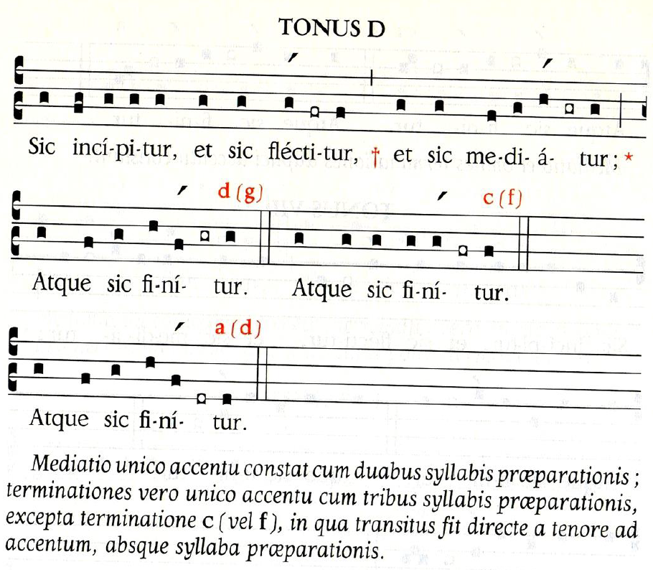
(See tone 4- same principles)

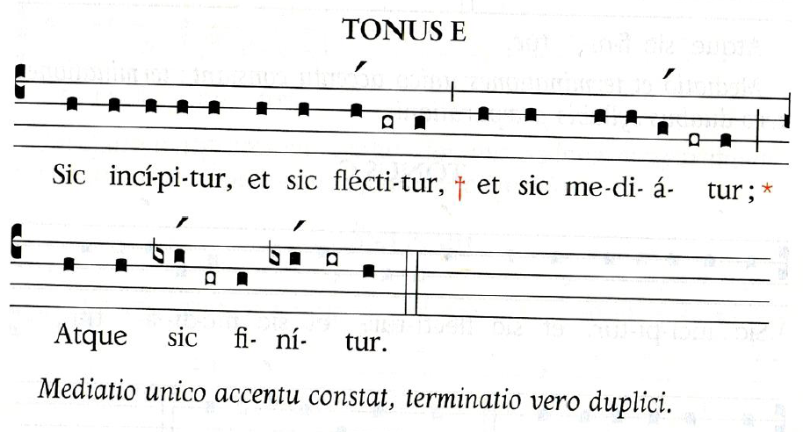
(without incipit) The Lord is my shepherd;*
there is nothing I shall want.
Fresh and green are the pastures*
where he gives me repose.
Near restful waters he leads me,*
to revive my drooping spirit.
When I call, answer me, O God of justice;*
from anguish you released me, have mercy and hear me!*
O men, how long will your hearts be closed,*
will you love what is futile and seek what is false?
It is the Lord who grants favors to those whom he loves;*
the Lord hears me whenever I call him.
Fear him; do not sin: ponder on your bed and be still*
Make justice your sacrifice, and trust in the Lord.
“What can bring us happiness?” many say.*
Let the light of your face shine on us, O Lord.
You have put into my heart a greater joy*
than they have from abundance of corn and new wine.
I will lie down in peace and sleep comes at once*
for you alone, Lord, make me dwell in safety.
Glory to the Father and to the Son*
And to the Holy Spirit

As it was in the beginning is now*
And will be forever. Amen

He guides me along the right path;*
he is true to his name.
If I should walk in the valley of darkness*
no evil would I fear.
You are there with your crook and your staff;*
with these you give me comfort.
You have prepared a banquet for me*
in the sight of my foes.
My head you have anointed with oil;*
my cup is overflowing.
Surely goodness and kindness shall follow me*
all the days of my life.
In the Lord’s own house shall I dwell*
for ever and ever.
Glory to the Father and to the Son*
And to the Holy Spirit
As it was in the beginning is now *
And will be forever. Amen
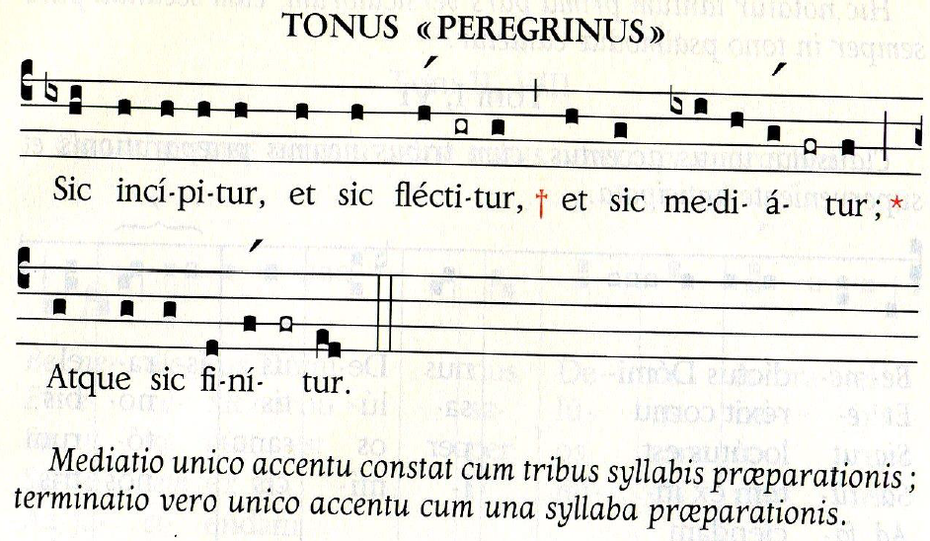
(without incipit) The Lord is my shepherd;*
there is nothing I shall want.
Fresh and green are the pastures*
where he gives me repose.
Near restful waters he leads me,*
to revive my drooping spirit.
When I call, answer me, O God of justice;*
from anguish you released me, have mercy and hear me!*
O men, how long will your hearts be closed,*
will you love what is futile and seek what is false?
It is the Lord who grants favors to those whom he loves;*
the Lord hears me whenever I call him.
Fear him; do not sin: ponder on your bed and be still*
Make justice your sacrifice, and trust in the Lord.
“What can bring us happiness?” many say.*
Let the light of your face shine on us, O Lord.
You have put into my heart a greater joy*
than they have from abundance of corn and new wine.
I will lie down in peace and sleep comes at once*
for you alone, Lord, make me dwell in safety.
Glory to the Father and to the Son*
And to the Holy Spirit

As it was in the beginning is now*
And will be forever. Amen

He guides me along the right path;*
he is true to his name.
If I should walk in the valley of darkness*
no evil would I fear.
You are there with your crook and your staff;*
with these you give me comfort.
You have prepared a banquet for me*
in the sight of my foes.
My head you have anointed with oil;*
my cup is overflowing.
Surely goodness and kindness shall follow me*
all the days of my life.
In the Lord’s own house shall I dwell*
for ever and ever.
Glory to the Father and to the Son*
And to the Holy Spirit
As it was in the beginning is now *
And will be forever. Amen
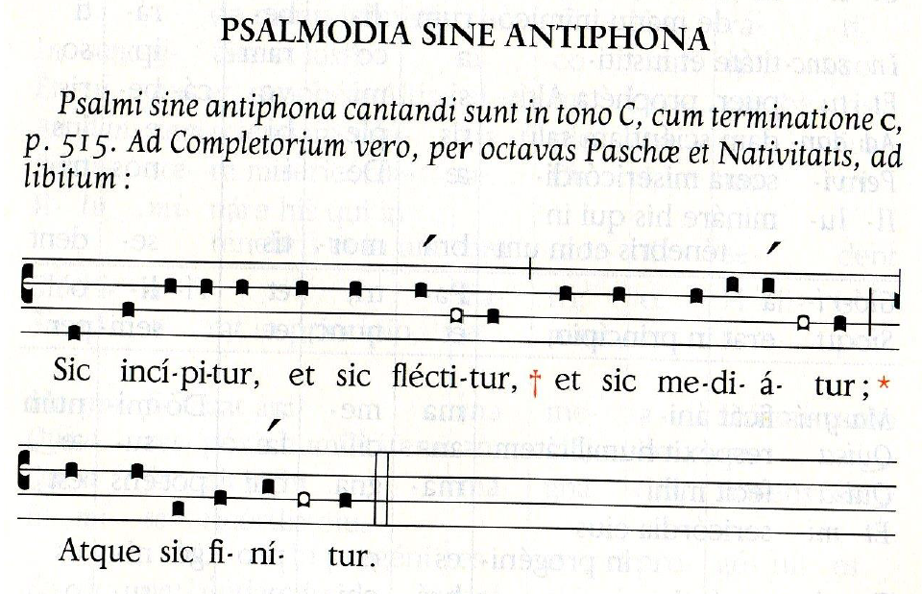
When I call, answer me, O God of justice;*
from anguish you released me, have mercy and hear me!*
O men, how long will your hearts be closed,*
will you love what is futile and seek what is false?
It is the Lord who grants favors to those whom he loves;*
the Lord hears me whenever I call him.
Fear him; do not sin: ponder on your bed and be still*
Make justice your sacrifice, and trust in the Lord.
“What can bring us happiness?” many say.*
Let the light of your face shine on us, O Lord.
You have put into my heart a greater joy*
than they have from abundance of corn and new wine.
I will lie down in peace and sleep comes at once*
for you alone, Lord, make me dwell in safety.
Glory to the Father and to the Son*
And to the Holy Spirit

As it was in the beginning is now*
And will be forever. Amen

(without incipit) The Lord is my shepherd;*
there is nothing I shall want.
Fresh and green are the pastures*
where he gives me repose.
Near restful waters he leads me,*
to revive my drooping spirit.
He guides me along the right path;*
he is true to his name.
If I should walk in the valley of darkness*
no evil would I fear.
You are there with your crook and your staff;*
with these you give me comfort.
You have prepared a banquet for me*
in the sight of my foes.
My head you have anointed with oil;*
my cup is overflowing.
Surely goodness and kindness shall follow me*
all the days of my life.
In the Lord’s own house shall I dwell*
for ever and ever.
Glory to the Father and to the Son*
And to the Holy Spirit
As it was in the beginning is now *
And will be forever. Amen

