O Virgo Splendens

O Virgo Splendens hic in monte celso,
Miraculis serrato
Fulgentibus ubique,
Quem fideles Conscendunt universi.

Eya, pietatis occulo placato,
Cerne ligatos fune peccatorum,
Ne infernorum ictibus graventur
Sed cum beatis tua prece vocentur.

O Virgin, shining brightly upon this high peaked mountain which all the faithful climb, everywhere your miracles abound!

Ah, with your gentle eyes of love
Behold those bound in the bonds of sin,
Lest they be tormented by the sting of Hell but that through your plea they be reckoned among the blessed!

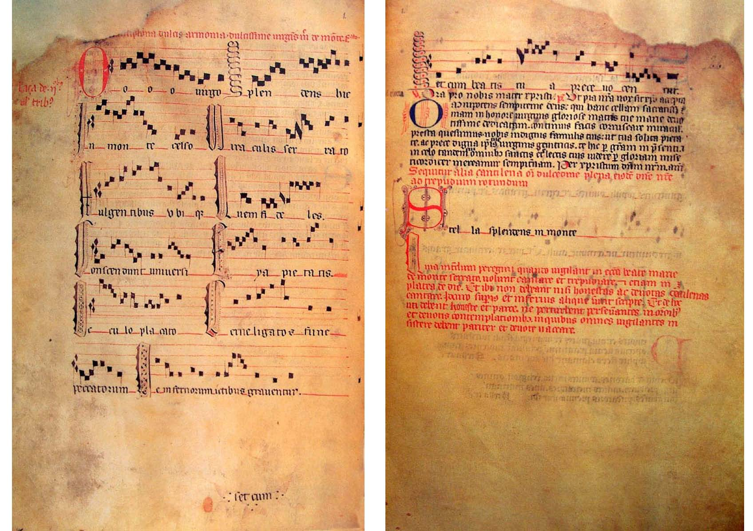
Fol. v21 – r22 from Llibre Vermell de Montserrat

Stella Splendens in Monte

Refrain:
Stella splendens in monte ut solis radium miraculis
serrato, exaudi populum.

Concurrunt unvisersi gaudentes populi,
divites et egeni, grandes et parvuli,
ipsum ingregiuntur, ut cernunt oculi,
et inde revertuntur graciis repleti.

Principes et magnates ex stirpe regia,
saeculi potestates optenta venia
peccaminum proclamant tundentes pectora.
Poplite flexo clamant hic: Ave Maria

Prelati et barones, comites incliti,
religiosi omnes atque presbyteri,
milites, mercatores, cives, marinari
burgenses, piscatores praemiantur ibi.

Rustici, aratores, nec non notarii,
Advocati, scultores, cuncti ligni fabri,
sartores et sutores, nec non lanifici,
artifices et omnes gratulantur ibi.

Reginae, comitissae,illustres dominae,
potentes et ancillae, juvenes, parvulae
virgines et antiquae, pariter viduae
conscendunt et hunc montem, et religiosae.

Coetus hii aggregantur hic ut exhibeant
vota regratiantur ut ipsa et reddant
aulam istam ditantes, hoc cuncti videant,
iocalibus ornantes, soluti redeant.

Cuncti ergo precantes sexus utriusque,
mentes nostras mundantes oremus devote
virginem gloriosam, matrem clementiae,
in coelis gratiosam sentiamus vere.

Refrain:
O Star, bright as the rays of the sun, ablaze with miracles, shinning on Montserrat, hear the people!

All the world joyfully comes together, rich and poor, great and small, they enter here to see with their own eyes, and return from there filled with grace.
Rulers and nobles of royal stirps, the mighty of the world, now pardoned of their sins call out on bended knee and beating their breasts cry; Hail Mary.
Prelates and barons, renowned counts, every monk and priest, soldiers, merchants, citizens, sailors, freemen, and fishermen, all are requited here.
Peasants, ploughmen, and scribes, advocates, masons, and carpenters, tailors, cobblers, and weavers, every craftsmen rejoices here.
Queens, countesses, and eminent ladies, powerful and lowly, young and tender maidens, and old women, widows and nuns, all climb this mountain.
All these people come together here to prove their vows, rejoicing for graces received. They enrich this shrine that all to see, adorning it with jewels, and return home spotless.
Therefore let us all, men and women, cleansing our hearts, beseech and devotedly pray that we may truly see the glorious and blessed virgin, mother of mercy, in heaven.

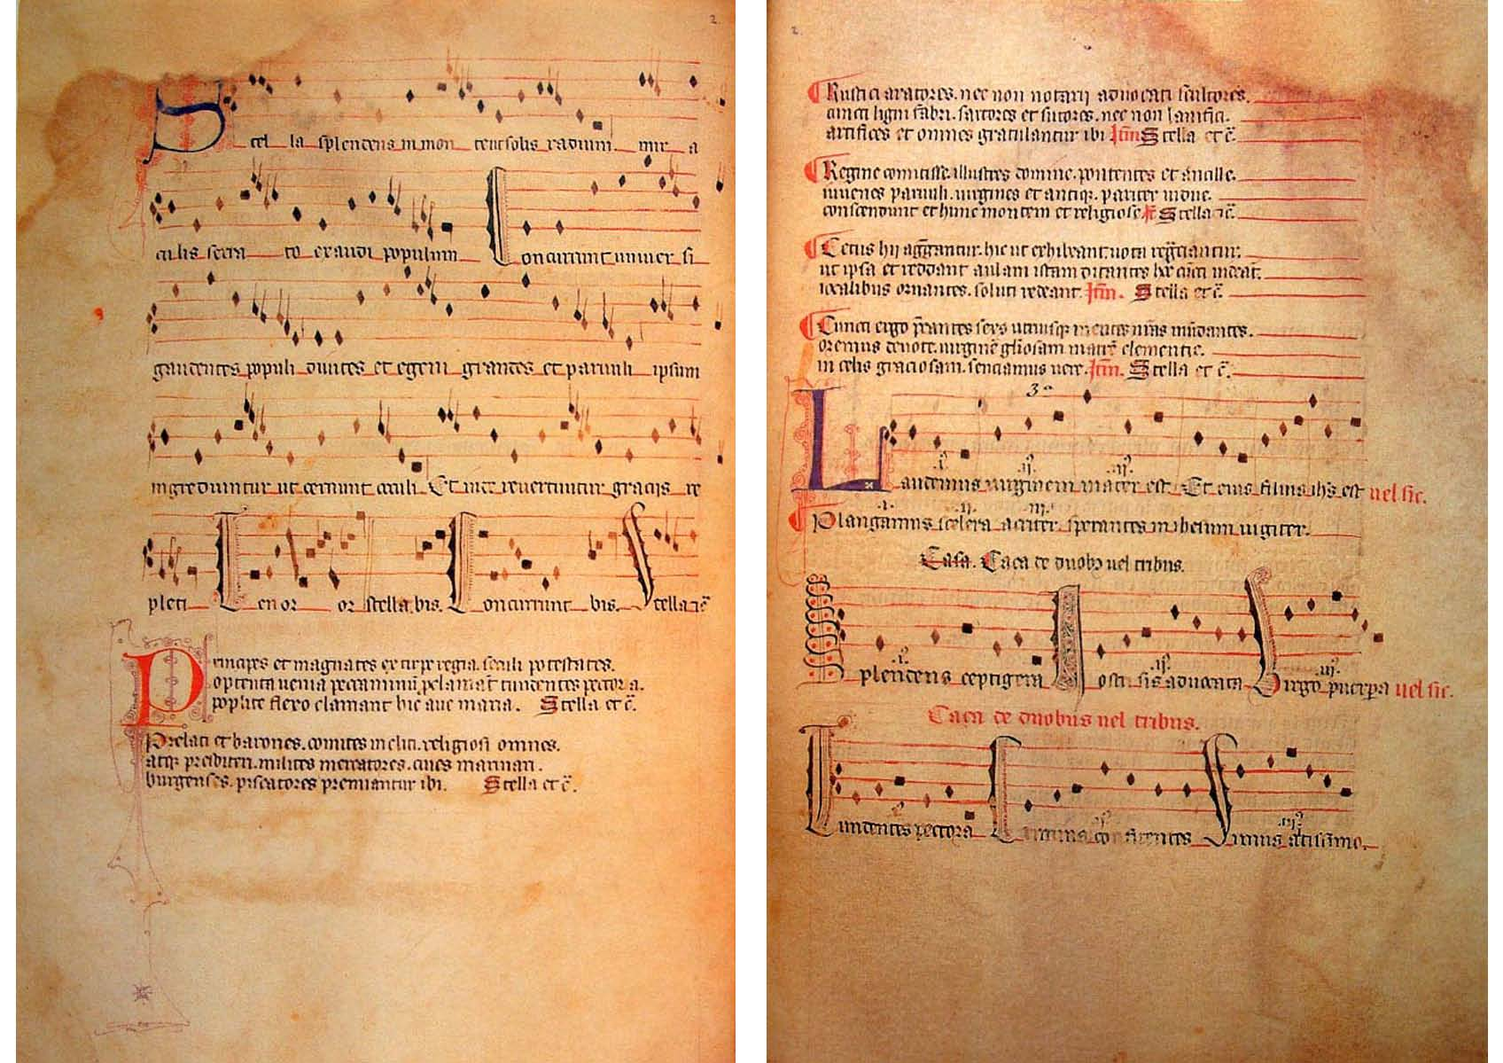
Fol. v22 – r23 from Llibre Vermell de Montserrat

Ad mortem festinamus

Refrain:
Ad mortem festinamus peccare desistamus.

Scribere proposui de contemptu mundano,
ut degentes seculi non mulcentur in vano.
Iam est hora surgere a somno mortis pravo.

Vita brevis breviter, in brevi finietur,
mors venit velociter quae neminem veretur.
Omnia mors perimit et nulli miseretur.

Ni conversus fueris et sicut puer factus,
et vitam mutaveris in meliores actus,
intrare non poteris regnum Dei beatus.

Tuba cum sonuerit dies erit extrema
et judex advenerit, vocabit sempiterna
electos in patria prescitos ad inferna.

Quam felices fuerint qui cum Christo regnabunt, facie ad faciem sic eum adspectabunt, Sanctus, Sanctus Dominus Sabaoth conclamabunt.

Et quam tristes fuerint qui eterne peribunt,
pene non deficient nec propter has obibunt:
Heu, heu miseri numquam inde exibunt.

Cuncti reges seculi et in mundo magnates
advertant et clarici omnesque postestates
fiant velut parvuli dimitant vanitates.

Heu, fratres karissimi, si digne contemplemus passionem Domini, amare et si flemus, ut pupillam oculi servabit ne peccemus.

Alma Virgo virginum, in celis coronata,
apud tuum filium sis nobis advocata,
et post hoc exilium occurrens mediata.

O mors, quam amara est memoria tua.
Vile cadaver eris. Cur non peccare vereris?
Vile cadaver eris. Cur intumescere quæris?
Vile cadaver eris, Ut quid peccuniam quæris?
Vile cadaver eris. Quid vestes pomposas geris?
Vile cadaver eris, Ut quid honores quæris?
Vile cadaver eris. Cur non paenitens confiteris?
Vile cadaver eris. Contra proximum non laeteris.

Refrain:
We are hurrying towards death, let us cease sinning.

I have resolved to write about the contempt of the world, that the living may not be worsted by pride/vainglory. Now is the hour to wake from death’s perverse sleep.

Life is short, and before long it will end, quickly and unmercifully death comes. Death extinguishes everything and has tenderness for no one.

Unless you repent and become like a child, and leave your wicked ways for holier ones, never will you enter the kingdom of God, reserved for the blessed.

When the trumpet sounds, the last day will end, and the judge will appear. He will call the elect home and the dammed to everlasting hell.

How happy are those, who will reign with Christ, for they will see him face to face. Holy, Holy is the Lord of Hosts will they shout.

How wretched are those, who will be forever dead, never will they be set free from their punishment and in chains will they perish. Woe to the wretched for they will never escape from there [hell].

Let earthly kings and powerful men of the world forsake their might. Let clerics and potentates become like children. Let all cast aside their pride/vainglory.

Oh, dearest brothers, if we devoutly contemplate our Lord’s passion, and bitterly weep, he will save us, the apple of his eye, from sin.

O loving virgin of virgins, crowned in heaven, be our advocate with your son, and after our exile meet us halfway [intercede for us].

O death, how bitter is the thought of you.
[Soon] You will be a fetid/vile corpse. Why do you not fear sin?
[Soon] You will be a fetid/vile corpse. You do you seek to swell up with anger/pride?
[Soon] You will be a fetid/vile corpse. Why do you long after riches?
[Soon] You will be a fetid/vile corpse. Why do you wear lavish clothes?
[Soon] You will be a fetid/vile corpse. Why do you seek earthly fame?
[Soon] You will be a fetid/vile corpse. Why do you not confess with a contrite heart?
[Soon] You will be a fetid/vile corpse. Do not rejoice in your neighbour’s misfortune.

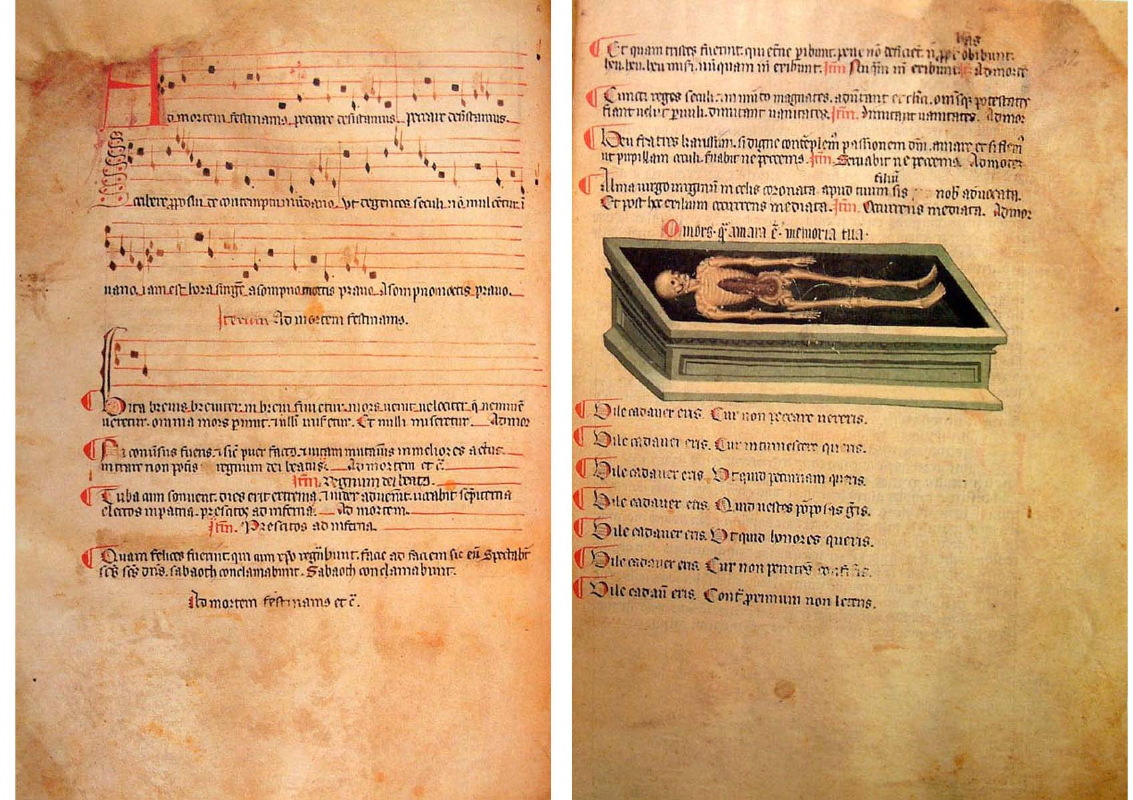
Fol. v26 – r27 from Llibre Vermell de Montserrat

