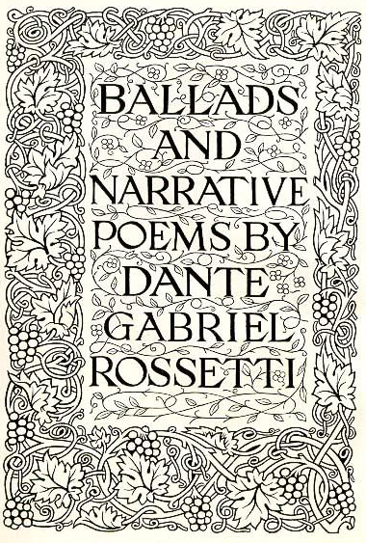
Come sing with Baltimore’s
Roman Catholic
Evensong Choir at
Mount Calvary Church
Vocalists seeking a Catholic choir dedicated to excellent liturgical music—especially Anglican and Gregorian chant, anthems, and classical hymnody—are invited to join this ensemble for the 2012-2013 year.
The choir sings Evensong (traditional-language Anglican Use, Roman Catholic vespers) one Sunday each month at 4:30 pm, preceded two Thursday evening rehearsals (7:00-8:45) and a Sunday warm- rehearsal at 3:30 pm.
Singers need general music-reading skills, some choral experience, a blending voice, and a cooperative spirit.
Choir members receive comprehensive, engaging instruction in choral musicianship, including sight-reading, chant notation, diction, and liturgical prayer.
Founded in 1842, Mount Calvary Church is now a Roman Catholic, Anglican Use parish in accord with the Apostolic Constitution Anglicanorum Coetibus of Pope Benedict XVI.
Visit www.MountCalvary.com for more information and to contact our choirmaster, Dr. Daniel Bennett Page.

