Since singing is so good a thing  I wish all men would learn to sing.  – William Byrd (1540-1623)  The Church knew what the Psalmist knew: Music praises God. Music … is the Church's greatest ornament.  – Igor Stravinsky (1882-1971)  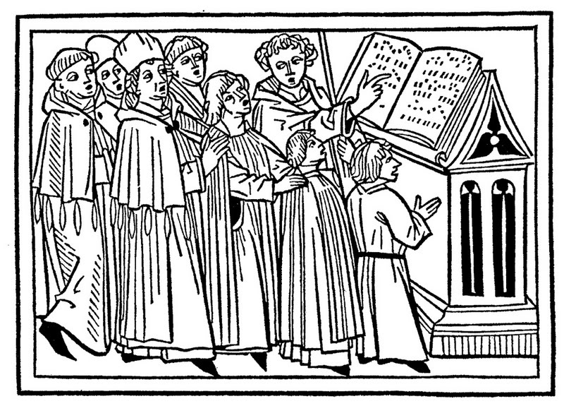  New singers are invited to join Mount Calvary Church’s Evensong Choir.  Who: Women, men, and young people with basic music reading skills, a blending voice, and a cooperative spirit. While this is a Catholic choir in the Anglican tradition, singers of all religious backgrounds may take part.  What: Leading sung prayer at Evensong (vespers) every Sunday afternoon. Our current repertory is mostly plainsong chant and classical hymnody, but will soon expand to include Anglican chant and motets.  When: We rehearse at 3:45 pm for the 4:30-5:15 liturgy.  How: Contact Mount Calvary’s choirmaster, Daniel Page, through the parish website, www.MountCalvary.com. | Since singing is so good a thing  I wish all men would learn to sing.  – William Byrd (1540-1623)  The Church knew what the Psalmist knew: Music praises God. Music … is the Church's greatest ornament.  – Igor Stravinsky (1882-1971)  New singers are invited to join Mount Calvary Church’s Evensong Choir.  Who: Women, men, and young people with basic music reading skills, a blending voice, and a cooperative spirit. While this is a Catholic choir in the Anglican tradition, singers of all religious backgrounds may take part.  What: Leading sung prayer at Evensong (vespers) every Sunday afternoon. Our current repertory is mostly plainsong chant and classical hymnody, but will soon expand to include Anglican chant and motets.  When: We rehearse at 3:45 pm for the 4:30-5:15 liturgy.  How: Contact Mount Calvary’s choirmaster, Daniel Page, through the parish website, www.MountCalvary.com.
Since singing is so good a thing  I wish all men would learn to sing.  – William Byrd (1540-1623)  The Church knew what the Psalmist knew: Music praises God. Music … is the Church's greatest ornament.  – Igor Stravinsky (1882-1971)  New singers are invited to join Mount Calvary Church’s Evensong Choir.  Who: Women, men, and young people with basic music reading skills, a blending voice, and a cooperative spirit. While this is a Catholic choir in the Anglican tradition, singers of all religious backgrounds may take part.  What: Leading sung prayer at Evensong (vespers) every Sunday afternoon. Our current repertory is mostly plainsong chant and classical hymnody, but will soon expand to include Anglican chant and motets.  When: We rehearse at 3:45 pm for the 4:30-5:15 liturgy.  How: Contact Mount Calvary’s choirmaster, Daniel Page, through the parish website, www.MountCalvary.com. | Since singing is so good a thing  I wish all men would learn to sing.  – William Byrd (1540-1623)  The Church knew what the Psalmist knew: Music praises God. Music … is the Church's greatest ornament.  – Igor Stravinsky (1882-1971)  New singers are invited to join Mount Calvary Church’s Evensong Choir.  Who: Women, men, and young people with basic music reading skills, a blending voice, and a cooperative spirit. While this is a Catholic choir in the Anglican tradition, singers of all religious backgrounds may take part.  What: Leading sung prayer at Evensong (vespers) every Sunday afternoon. Our current repertory is mostly plainsong chant and classical hymnody, but will soon expand to include Anglican chant and motets.  When: We rehearse at 3:45 pm for the 4:30-5:15 liturgy.  How: Contact Mount Calvary’s choirmaster, Daniel Page, through the parish website, www.MountCalvary.com.

